**Feed Task Scheduler**

**Go to DC-JMSDEV**

1. **Telstra New feed**

* Save the new file in location (C:\Feed)
* Edit filename ( C:\Feed)

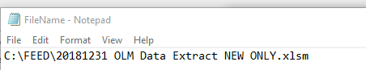

1. **Optus New Feed**

* Save the new file in location (C:\FEED\OptusNewFeed)
* Edit filename ( C:\FEED\OptusNewFeed)

1. **Telstra Change Feed**

* Save the new file in location (C:\FEED\TelstraChangefeed)
* Edit filename ( C:\FEED\TelstraChangefeed)

**Task Scheduler :**

1. **Telstra New Feed**